  

WIRELESS CHARGER

### A MINOR PROJECT-II REPORT

**Submitted by**

SNEHA R (927621BEC202)

SUJITHA V (927621BEC222)

SUNMATHI S (927621BEC223)

YAKSHINI M (927621BEC244)

### BACHELOR OF ENGINEERING

in

### DEPARTMENT OF ELECTRONICS AND COMMUNICATION ENGINEERING

**M.KUMARASAMY COLLEGE OF ENGINEERING**

(Autonomous)

### KARUR – 639 113

**APRIL 2023**

### M.KUMARASAMY COLLEGE OF ENGINEERING, KARUR

### BONAFIDE CERTIFICATE

Certified that this **18ECP104L-Minor Project II** project report **“WIRELESS CHARGER”** is the bonafide work of “SNEHA R (927621EC202) SUJITHA V (927621BEC222) SUNMATHI S (927621BEC223) YAKSHINI M (927621BEC244)”who carried out the project work under my supervision in the academic year 2022- 2023 - EVEN.

### SIGNATURE SIGNATURE

**Dr.S.PALANIVEL RAJAN, M.E., M.B.A., Mrs.P.YUVARANI,M.E.,(Ph.D).,**

### (Ph.D).,D.Litt(USA).,

### HEAD OF THE DEPARTMENT, SUPERVISOR,

Associate Professor, Assistant Professor,

Department of Electronics and Department of Electronics and

Communication Engineering, Communication Engineering,

M.Kumarasamy College of M.Kumarasamy College of

Engineering, Thalavapalayam, Engineering, Thalavapalayam,

Karur-639113. Karur-639113.

This Minor project-II report has been submitted for the **18ECP104L – Minor Project-II** Review held at M.Kumarasamy College of Engineering, Karur on _______________.

**PROJECT COORDINATOR**

### INSTITUTION VISION AND MISSION

### Vision

To emerge as a leader among the top institutions in the field of technical education

### Mission

**M1:** Produce smart technocrats with empirical knowledge who can surmount the global challenges

**M2:** Create a diverse, fully engaged, learner-centric campus environment to provide quality education to the students

**M3:** Maintain mutually beneficial partnerships with our alumni, industry, and Professional associations Vision of the Department

**DEPARTMENT VISION,MISSION,PEO,PO AND PSO**

### Vision

To empower the Electronics and Communication Engineering students with emerging technologies, professionalism, innovative research, and social responsibility.

### Mission

**M1:** Attain the academic excellence through innovative teaching learning process,

research areas & laboratories and Consultancy projects.

**M2:** Inculcate the students in problem solving and lifelong learning ability.

**M3:** Provide entrepreneurial skills and leadership qualities.

**M4:** Render the technical knowledge and skills of faculty members.

III

### Program Educational Objectives

**PEO1: Core Competence:** Graduates will have a successful career in academia or industry associated with Electronics and Communication Engineering.

**PEO2: Professionalism:** Graduates will provide feasible solutions for the challenging problems through comprehensive research and innovation in the allied areas of Electronics and Communication Engineering.

**PEO3: Lifelong Learning:** Graduates will contribute to the social needs through lifelong learning, practicing professional ethics and leadership quality

### Program Outcomes

**PO 1: Engineering knowledge:** Apply the knowledge of mathematics, science, engineering fundamentals, and an engineering specialization to the solution of complex engineering problems.

**PO 2: Problem analysis:** Identify, formulate, review research literature, and analyze complex engineering problems reaching substantiated conclusions using first principles of mathematics, natural sciences, and engineering sciences.

**PO 3: Design/development of solutions:** Design solutions for complex engineering problems and design system components or processes that meet the specified needs with appropriate consideration for the public health and safety, and the cultural, societal, and environmental considerations.

**PO 4: Conduct investigations of complex problems:** Use research-based knowledge and research methods including design of experiments, analysis and Interpretation of data, and synthesis of the information to provide valid conclusions.

**PO 5: Modern tool usage:** Create, select, and apply appropriate techniques, resources, and modern engineering and IT tools including prediction and modeling to complex engineering activities with an understanding of the limitations.

**PO 6: The engineer and society:** Apply reasoning informed by the contextual knowledge to assess societal, health, safety, legal and cultural issues, and the consequent responsibilities relevant to the professional engineering practice.

**PO 7: Environment and sustainability:** Understand the impact of the professional engineering solutions in societal and environmental contexts, and demonstrate the knowledge of, and need for sustainable development.

**PO 8: Ethics:** Apply ethical principles and commit to professional ethics and responsibilities and norms of the engineering practice.

**PO 9: Individual and teamwork:** Function effectively as an individual, and as a member or leader in diverse teams, and in multidisciplinary settings.

**PO 10: Communication:** Communicate effectively on complex engineering activities with the engineering community and with society at large, such as, being able to comprehend and write effective reports and design documentation, make effective presentations, and give and receive clear instructions.

**PO 11: Project management and finance:** Demonstrate knowledge and understanding of the engineering and management principles and apply these to one’s own work, as a member and leader in a team, to manage projects and in multidisciplinary environments.

**PO 12: Life-long learning:** Recognize the need for and have the preparation and ability to engage in independent and life-long learning in the broadest context of technological change.

### Program Specific Outcomes

**PSO1:** Applying knowledge in various areas, like Electronics, Communications, Signal processing, VLSI, Embedded systems etc., in the design and implementation of Engineering application.

**PSO2:** Able to solve complex problems in Electronics and Communication Engineering with analytical and managerial skills either independently or in team using latest hardware and software tools to fulfil the industrial expectations.

|  |  |
| --- | --- |
| **Abstract** | **Matching with POs, PSOs** |
| Super Capacitor, Torch Light, MOSFET, Voltage Regulator, LEDs | PO1, PO2, PO3, PO4, PO5, PO6, PO7, PO8, PO9,  PO10, PO11, PO12, PSO1, PSO2 |

## ACKNOWLEDGEMENT

Our sincere thanks to **Thiru.M.Kumarasamy, Chairman** and **Dr.K.Ramakrishnan, Secretary** of **M.Kumarasamy College of Engineering** for providing extraordinary infrastructure, which helped us to complete this project in time.

It is a great privilege for us to express our gratitude to **Dr.B.S.Murugan., B.Tech., M.Tech., Ph.D., Principal** for providing us right ambiance to carry out this project work.

We would like to thank **Dr.S.Palanivel Rajan, M.E., M.B.A., Ph.D., D.Litt (USA)., Professor and Head**, **Department of Electronics and Communication Engineering** for his unwavering moral support and constant encouragement towards the completion of this project work.

We offer our wholehearted thanks to our **Project Supervisor,Mrs.P.Yuvarani**, **M.E.,(Ph.D).,Assistant professor** Department of Electronics and Communication supervision, kind cooperation, valuable suggestions and support rendered in making our project to be successful.

We would like to thank our **Minor Project Co-ordinator**, **Dr.E.Dinesh, M.E., Ph.D.,Associate Professor**, Department of Electronics and Communication Engineering for his kind cooperation and culminating in the successful completion of this project work. We are glad to thank all the Faculty Members of the Department of Electronics and Communication Engineering for extending a warm helping hand and valuable suggestions throughout the project. Words are boundless to thank our Parents and Friends for their motivation to complete this project successfully.

**ABSTRACT**

A wireless charger using a supercapacitor is a novel approach that offers several advantages over traditional battery-based chargers. Supercapacitors have a higher power density than batteries, which makes them ideal for high-power applications such as wireless charging. In this design, a supercapacitor is used as the energy storage device, and a circuit is designed to convert the DC voltage from the supercapacitor to the AC voltage required for wireless charging.The process of building a wireless charger using a supercapacitor involves selecting a wireless charging standard, choosing a supercapacitor with the appropriate voltage rating and capacity, designing a circuit that can convert the DC voltage to the required AC voltage, building the charger, and testing it to ensure that it works correctly.While supercapacitors have some advantages over batteries, such as a higher power density and longer lifespan, they also have some limitations, such as a lower energy density. Therefore, a wireless charger using a supercapacitor may need to be recharged more frequently than a battery-based charger. Nonetheless, this approach represents a technology for wireless charging, particularly for high-power applications.

|  |  |  |  |
| --- | --- | --- | --- |
| **CHAPTER**  **No.** |  | **CONTENTS** | **PAGE**  **No.** |
|  | **Institution Vision and Mission** | | iii |
|  | **Department Vision and Mission** | | iii |
|  | **Department PEOs, POs and PSOs** | | iv |
|  | **Abstract** |  | viii |
|  | **List of Tables** | | x |
|  | **List of Figures** | | x |
|  | **List of Abbreviations** | | xi |
| **1** | **INTRODUCTION** | | 12 |
|  | 1.1 | Wireless sensor Network | 12 |
|  | 1.2 | Sensor Node | 13 |
|  | 1.3 | Thesis Objective | 14 |
| **2**  **3** | **LITERATURE SURVEY**  **EXISTING SYSTEM** | | 15  18 |
| **4** | **PROPOSED SYSTEM`** | | 19 |
|  | 4.1 | System Sizing | 19 |
|  | 4.2 | System Modeling | 20 |
| **5** | **HARDWARE IMPLEMENTATION** | | 25 |
| **6** | **RESULT AND DISCUSSION** | | 30 |
| **7** | **CONCLUSION** | | 33 |
| **8** | **REFERENCES** | | 35 |

**TABLE OF CONTENTS**

# LIST OF TABLE

|  |  |  |
| --- | --- | --- |
| **TABLE NO** | **TITLE** | **PAGE**  **NO** |
| 1.1  1.2  1.3 | Power density of energy harvesting technology  Panel characteristics  Parameters of Supercapacitor | 17  27  32 |

# 

**LIST OF FIGURES**

|  |  |  |
| --- | --- | --- |
| **FIGURE NO** | **TITLE** | **PAGE**  **NO** |
| 1.1 | Cycle of Data Sensing | 21 |
| 1.2 | Battery capacity degradation | 21 |
| 1.3 | Equivalent Circuit of Solar Cell | 23 |
| 1.4 | Discharge Controller | 25 |
| 1.5 | Supercapacitor Charge | 26 |
| 1.6 | LAUNCHXL-F28027 Board Overview | 28 |
| 1.7 | Battery Charge | 29 |

# LIST OF ABBREVIATIONS

PV - Photovoltaics

VPV - Panel Voltage

IPV - Panel Current

D - Duty Cycle

­VBUS  - Internal DC Bus Voltage

PIN - Input Power

VSC - Supercapacitor Voltage

# CHAPTER 1 INTRODUCTION

**1.1 Wireless Sensor Network**

Wireless Sensor Network (WSN) is the second largest network after internet in the world, and it stands first in the list of ten emerging technologies. WSN consist of a large number of sensor nodes spatially distributed in measurement field for sensing, transmitting and receiving information for performing tasks such as habitat monitoring, military surveillance, Smart buildings, environment monitoring such as greenhouse, water quality monitoring. WSN’s are used for collecting the data when measurement field is large or located in difficult geographical terrain where round the clock surveillance is not possible.The tiny sensor nodes are responsible for detection and transmission of data to the control room, the application requires them to be energy autonomous for performing the task. Conventionally, these sensor nodes are battery powered which require frequent replacement as the battery can sustain limited charge-discharge cycles without considerable loss in capacity.The problem of powering a large number of sensor nodes densely deployed in the measurement field is restricting the use of WSN'S as it increases their operating costs. The possible solution to the above problem is to use energy harvesting from the ambient environment to power these nodes, which can b–e vibration, solar, acoustic noise etc. performance of each energy source depends on the environment of the measurement field. Batteries are a matured technology and offer very high energy density in terms of charge storage. To extend the rechargeable battery life as far as possible and keep the ‘high performance’ of the battery efficient charge-discharge control is required.

But this control is very difficult to implement if the nature of energy source is a variant. With all its disadvantages of like energy density, high leakage charge supercapacitor is no way near to replace the battery as the storage mechanism, but it can offer its advantage in terms of virtually unlimited charge and discharge cycles In this work battery-supercapacitor, hybrid storage scheme is tested for its performance related to the lifetime of the sensor node in terms of charge-discharge cycles of battery since the battery is the limiting factor as it can sustain a limited number of charge-discharge cycles. A power manager is used for efficient routing of energy.

# Sensor Node

Sensor node is responsible for sensing, processing and receiving of data associated with the application. It consists of a processor capable of wireless transmission to which various sensors are interfaced. The sensor node doesn’t send raw data it uses its processing ability to carry out simple computations and transmit partially processed data, for performing these functions it is equipped with a power source.MICA2 Mote is generally used as a sensor node [4]. It is a tiny microcomputer with a TinyOS (TOS) Distributed Software Operating System. It’s updated version MICA2DOT Mote is a third-generation mote module used for enabling low-power, wireless, sensor networks. The MICA2DOT is similar to the MICA2, except for its quarter-sized (25mm) form factor and reduced input/output channels.As the primary focus of this work is on increasing the lifetime of sensor node rather than reducing its power requirement. Therefore, Arduino Uno is selected as the processor, the reason being the ease with which it can be programmed and interfaced with various sensors. With the help of transmitter/receiver module, Arduino is capable of wireless communication. The entire assembly of Arduino, receiver/transmitter module, and the sensors is named as the sensor node.

# Objectives

The project had as its objectives the following aspects

* + - * + To implement a wireless mobile charger.
        + To delimitate the advantages, disadvantages and applications for the project.
        + To present possible solutions, if any, to solve or mitigate the impact of the disadvantages.

**CHAPTER 2**

**LITERATURE SURVEY**

**2.1 "Performance analysis of a wireless charger for mobile devices using electromagnetic induction" by H. Park et al. (2020)**

This present presents a performance analysis of a wireless charger for mobile devices using electromagnetic induction technology. The authors aim to evaluate the efficiency and power transfer capability of the charger under various conditions.

The wireless charger consists of a transmitter coil, a receiver coil, and a rectifier circuit. The transmitter coil generates a magnetic field, which induces a voltage in the receiver coil. The rectifier circuit rectifies the voltage and charges the battery of the mobile device.

The authors conducted experiments to evaluate the efficiency and power transfer capability of the wireless charger under various conditions, such as distance between the transmitter and receiver coils, orientation of the coils, and charging current. They also compared the performance of the wireless charger with that of a conventional wired charger.

The results showed that the efficiency of the wireless charger was affected by the distance and orientation of the coils, as well as the charging current. The authors found that the wireless charger achieved a similar level of efficiency to the wired charger under optimal conditions.

Overall, this study provides insights into the performance and limitations of wireless chargers using electromagnetic induction technology for mobile devices. The authors suggest that further research is needed to improve the efficiency and power transfer capability of wireless chargers for practical use.

**2.2 "Design and implementation of a wireless charger for smartphones using magnetic resonance technology" by H. Kim et al. (2021)**

This project presents the design and implementation of a wireless charger for smartphones using magnetic resonance technology. The authors aim to improve the efficiency and charging speed of wireless charging for smartphones by using magnetic resonance technology.

The wireless charger consists of two coils: a transmitter coil and a receiver coil. The transmitter coil is connected to a power source and generates a magnetic field, which induces a voltage in the receiver coil. The voltage is rectified and used to charge the smartphone battery.

The authors optimized the design of the coils and the circuitry to improve the efficiency of the wireless charging system. They also conducted experiments to evaluate the performance of the system in terms of charging speed and temperature.

The results showed that the wireless charger using magnetic resonance technology achieved a higher efficiency and charging speed compared to conventional wireless chargers using electromagnetic induction. The authors also found that the temperature of the smartphone during charging was lower with the magnetic resonance technology, which can help to prolong the battery life.

Overall, this study demonstrates the potential of magnetic resonance technology for improving the efficiency and performance of wireless charging for smartphones. It also provides insights into the design and optimization of wireless charging systems using magnetic resonance technology.

**2.3 "Design and optimization of a wireless charger for smartwatches" by J. Lee et al. (2021)**

This project presents the design and optimization of a wireless charger for smartwatches using magnetic resonance technology. The authors aim to improve the charging speed and efficiency of wireless charging for smartwatches.

The wireless charger consists of two coils: a transmitter coil and a receiver coil. The transmitter coil is connected to a power source and generates a magnetic field, which induces a voltage in the receiver coil. The voltage is rectified and used to charge the smartwatch battery.

The authors optimized the design of the coils and the circuitry to improve the efficiency of the wireless charging system. They also conducted experiments to evaluate the performance of the system in terms of charging speed and temperature.

The results showed that the optimized wireless charger achieved a higher charging speed and efficiency compared to conventional wireless chargers. The authors also found that the temperature of the smartwatch during charging was lower with the optimized wireless charger, which can help to prolong the battery life.

The authors suggest that the optimized wireless charger can be used for various types of smartwatches, including those with different battery capacities and shapes. They also highlight the potential of magnetic resonance technology for improving the efficiency and performance of wireless charging for wearable devices.

Overall, this study demonstrates the importance of optimization in the design of wireless chargers for smartwatches, and provides valuable insights into the potential of magnetic resonance technology for improving the efficiency and performance of wireless charging for wearable devices.

**CHAPTER 3**

**EXISTING SYSTEMS**

There are several existing wireless charging systems available in the market. Some popular examples include:

**Qi wireless charging:** This is a popular standard for wireless charging that uses inductive charging technology. It is widely used in smartphones, tablets, and other portable devices.

**Powermat wireless charging:** This system also uses inductive charging technology and is commonly used in public spaces such as airports, cafes, and restaurants.

**Airfuel wireless charging:** This system uses a combination of inductive and resonant wireless charging technology and is compatible with multiple devices.

**WiTricity wireless charging:** This system uses magnetic resonance technology to wirelessly charge devices. It has applications in automotive, industrial, and consumer electronics.

**Energeous WattUp wireless charging:** This system uses radio frequency (RF) technology to wirelessly charge devices. It can charge multiple devices at once and has a range of up to 15 feet.

All of these systems use different wireless charging technologies, and they have different advantages and disadvantages. Some are more widely used than others, while some have specific applications in certain industries.

**CHAPTER 4**

Advantages

9

AdvantaCHAPTER 4

## PROPOSED SYSTEM

## "Proposed systems" typically refers to new or planned systems that have been proposed or designed but have not yet been fully implemented or deployed. These systems may be software applications, hardware devices, or other technological solutions that are intended to address specific needs or problems in a particular domain or industry.The process of proposing a new system typically involves conducting a thorough analysis of the problem or opportunity, identifying potential solutions, and evaluating their feasibility, cost, and expected benefits. Once a proposed system has been fully designed and documented, it may go through further stages of development, testing, and deployment before it is ready for use.

## 4.1.1 System Sizing

## 4.1.1.1 Power Consumption of the Sensor Node

## The power consumption of a sensor node depends on various factors such as the type of sensor, the sampling rate, the communication protocol, and the processing power of the node. Typically, a sensor node consists of a sensing element, a processing unit, a communication module, and a power source. The sensing element is responsible for measuring the physical parameter of interest, such as temperature, humidity, or light. The power consumption of the sensing element depends on the type of sensor and the sampling rate. For example, an accelerometer sensor consumes less power compared to a camera sensor. The processing unit is responsible for processing the data collected by the sensing element. The power consumption of the processing unit depends on the complexity of the algorithm used for processing the data. The communication module is responsible for transmitting the data to a gateway or a base station. The power consumption of the communication module depends on the communication protocol used and the distance between the sensor node and the gateway. Finally, the power source of the sensor node also plays a critical role in determining its power consumption. The power source can be a battery, a solar cell, or a combination of both. The battery capacity and the efficiency of the charging circuitry can affect the power consumption of the sensor node. In general, reducing the power consumption of the sensor node is critical for increasing the lifespan of the power source and minimizing the maintenance costs of the sensor network. This can be achieved by optimizing the sampling rate, reducing the processing complexity, and using low-power communication protocols.

## 4.2.1 Storage Sizing

* + - 1. **Battery Sizing**

The sizing of a supercapacitor for a particular application depends on the power and energy requirements of the system. Supercapacitors are characterized by their capacitance and maximum voltage rating. The capacitance determines the energy storage capacity of the supercapacitor, while the maximum voltage rating determines the voltage range in which the supercapacitor can operate.The actual capacity of the battery will be higher than the minimum size required by the energy storage requirements. For this work, a Li-ion battery of capacity 700 mAh is chosen for energy storage. The charge/discharge depth is reduced to 30.744/700 (0.044C) and would result in a great increase in cycle life.

## Supercapacitor Sizing

Supercapacitor has following two functions in the power circuit:

* + - * It supplies the peak demand when power from solar is not available.
      * It clamps the DC bus voltage to a constant value.

This only decides the lower limit of the supercapacitor rating, for finding the actual storage size a detailed SIMULINK model is developed (Section 4) which is run for several hours and batteries charge/discharge cycles are plotted as the function of the capacity of the supercapacitor.

## System Modelling

**4.2.1 Solar Panel Modelling**

A solar cell is a solid electric device which consists of a p-n junction fabricated from a semiconductor material of moderate band-gap (usually silicon). It behaves as a normal p-n junction diode in dark and has non-linear V-I characteristics [21]. However, in the presence of light, it absorbs photons having energy greater than the band gap energy. This results in the creation of electron-hole pairs [22]. These charge carriers are separated by internal electric field and result in a current proportional to incident photons.A simplest equivalent circuit of a solar cell is shown in fig. (3.9). It consists of a current source in parallel with a diode [8]. The output of the current source is proportional to the incident photon flux this current is called photocurrent. During darkness, the solar cell is not active and behave as an ordinary p-n junction diode and this gets modeled as a diode in the equivalent circuit [32]. It produces neither a current nor a voltage. This comes into action whenever a potential difference exists between the terminals of the solar cell and constitutes a current called Dark current.

Following are the parameters which are needed to be considered for accurate modeling of PV cell: -

* + - 1. Temperature dependence of the diode saturation current (reverse) IS.
      2. Temperature dependence of the photo current Iph.
      3. Series resistance R1 [20], representing internal losses due to current flow.
      4. Shunt resistance R2 [20], in parallel with the diode, this corresponds to the leakage current.

## 4.2.2 Power Management Algorithm

The role of the Power Manager in the proposed architecture has been discussed in section 2. This section contains the detailed Simulink model of power management algorithm which is based on six different states. These states are further divided into two groups depending on power from solar is available or not.States of Power Management Algorithm when Solar Power (PSOLAR) is available:

**OFF State: -** All the storages are discharged, all the converters are disabled.

**Soft Start: -** PSOLAR is greater than the power required by controller to turn on.

**Battery Charge: -** This mode is enabled when VSC reaches 1.9 Volts, this ensures that the system has enough energy to supply constant current for battery charging.

**Overvoltage: -** When VSC reaches to a voltage greater than its maximum voltage limit this mode gets activated and requires MPPT to be disabled as PSOLAR is greater than the load and battery charging requirement.

**Disable Battery Charge: -** When battery voltage reaches at floating value (4.2 Volts).

**Battery Charge Supercapacitor: -** This mode is activated just before the arrival of peak load and depends on the duty of the data sensing. During this mode, supercapacitor is drip charged from the battery to a value sufficient enough to supply peak load.Power manager switches the system from one mode to other by tracking battery voltage, input power, and supercapacitor voltage.

# Controllers

## 4.2.2.1 Battery Charge-Discharge Controller

### Charge Controller

For avoiding capacity degradation constant voltage charging mode [10] is not used so the charge controller has to control the charge current only, a variable duty cycle generator based on hysteresis control is used as the charge controller.

### Discharge Controller

Two types of discharge controllers are used one for providing the load current to the system and second (Battery charge Scap Controller) for charging supercapacitor

when PSOLAR is not available. The need for this controller arrives due to very small impedances of battery and supercapacitor, direct charging will result in a very high current (about 500 Ampere's) which will destroy the battery.

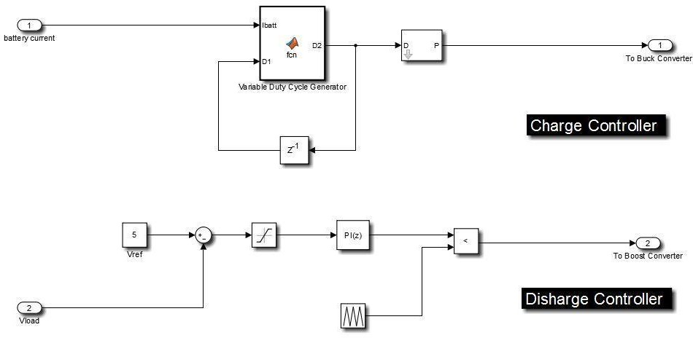

**Fig. 1.4. Discharge Controller**

## Supercapacitor Charge-Discharge Controller

A single double loop PI controller is used for implementing charge-discharge controller, the outer loop is slow acting and act as master and decides the reference for inner loop which is fast in action and acts as slave to the outer loop.

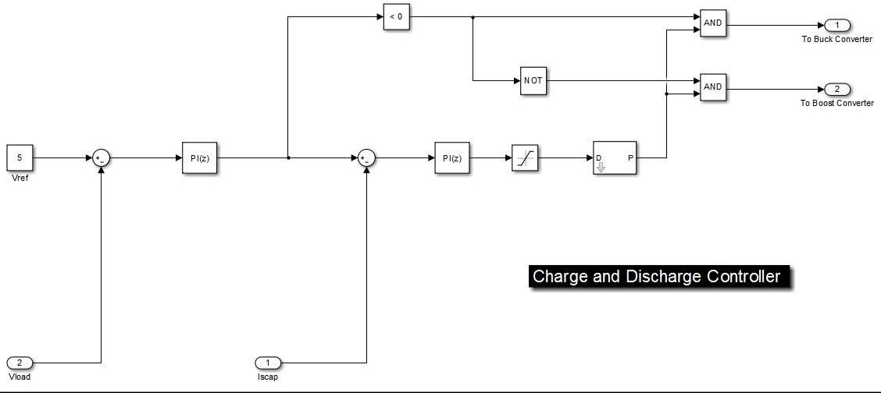

**Fig. 1.5 Supercapacitor Charge**

# CHAPTER 5

# HARDWARE IMPLEMENTATION

## Specification of the Components Used

|  |  |  |
| --- | --- | --- |
| Parameter | Value | |
| VOC | 11.6 | Volt’s |
| ISC | 0.61 | Ampere’s |
| RS | 0.1 Ohms | |
| RP | 415.405 Ohms | |
| VMP | 6.6 Volt’s | |
| IMP | 0.41 | Ampere’s |
| PMAX. | 5 Watt’s | |

Table 1.2

## Microcontroller

For implementing power manager and different controllers a c2000 f28027 Picolo Launchpad of Texas Instruments is used.

## Supercapacitor

SAMWHA Green-cap (ELDC) having following characteristics [27] is used.

|  |  |
| --- | --- |
| Rated Voltage | 2.7 Volts |
| Capacitance | 400 Farad |
| ESR 1khz | 3.0 milli Ohm |
| ESR DC | 5.0 milli Ohm |
| LC (72 Hours) | 1.08 mA |
| Max. Continuous Current Rating | 22 Ampere’s |
| Max. Peak Current | 180 Ampere’s |
| Specific Energy | 5.79 Wh/Kg |

Table 1.2

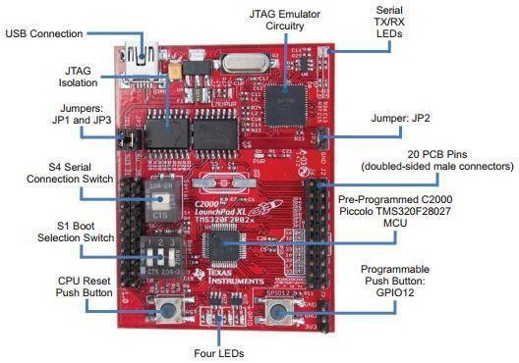

### Fig. 1.6 LAUNCHXL-F28027 Board Overview

|  |  |
| --- | --- |
| Processor | TMS320F28027 32-bit |
| Operating frequency | 60 MHz |
| Memory | 32K Flash |
| RAM | 6K |
| HRPWM Channels | 4 |

Table 1.2

## Programing model of MPPT for implementation on c2000 board

This MPPT model is run in a current loop which is hardware triggered, this interrupt is generated by end of ADC conversion. In the current loop, the ADC conversion is synchronized with ePWM output and the start conversion is triggered at the end of the period. The reason for this synchronization is to reduce the time lag in the control. For the faster execution of the current loop, it is run in the code_ramfuncs memory section.

## Programing Model of Battery Controller for implementation on c2000 board

As the battery controller is also taking analog input so it also requires a loop which is interrupt triggered and helps to synchronize the control with ADC conversion. Therefore, like MPPT control, the logic for battery control is also placed in the current loop and ADC start of conversion is synchronized with output PWM pulses. A rate transition block is placed in between the logic and ADC conversion block, this is done to stabilize the output.

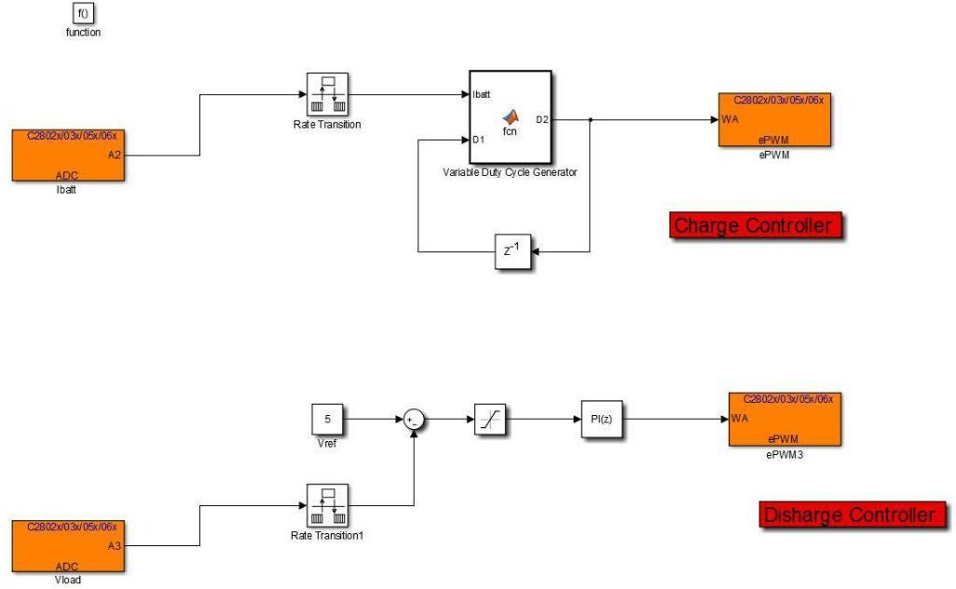

**Fig. 1.7 Battery Charge/Discharge Controller**

## 4.6 Programming model of Supercapacitor controller for implementation on c2000 board

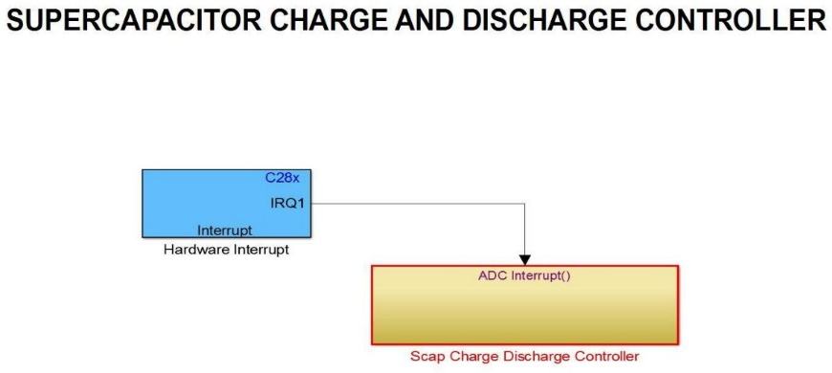The programming model of the supercapacitor is same as that of battery controller as both are using a PI controller in the closed loop control.

**Fig. 1.8 Supercapacitor Charge/Discharge Controller**

# CHAPTER 5

# RESULTS AND DISCUSSION

A wireless charger using a supercapacitor has the potential to provide faster charging times, longer cycle life, and a more convenient charging experience for mobile devices. The use of a supercapacitor can allow for a high-power density and fast charge and discharge rates, making it an ideal choice for wireless charging applications. Additionally, the elimination of cords and cables can provide a more convenient and hassle-free charging experience. However, as mentioned earlier, the supercapacitor sizing and charging circuitry must be carefully designed to ensure safe and reliable operation.

# CHAPTER 6

# CONCLUSIONS AND FUTURE WORK

# In conclusion, a wireless charger using a supercapacitor offers several advantages over traditional battery-based chargers. The supercapacitor can store energy quickly and release it rapidly, making it an ideal choice for wireless charging applications. Moreover, supercapacitors have a longer cycle life than batteries, which means they can last longer without needing to be replaced. This makes them a more cost-effective solution in the long term. The proposed system of a wireless charger using a supercapacitor can provide a reliable and efficient charging solution for mobile devices. The use of a supercapacitor allows for a fast charging rate, and the wireless technology eliminates the need for cords and cables, providing a more convenient charging experience. However, the supercapacitor sizing and charging circuitry must be carefully designed to ensure safe and reliable operation. In addition, the cost of supercapacitors is still higher than traditional batteries, which may make the system more expensive. Overall, a wireless charger using a supercapacitor is a promising solution that can provide faster and more convenient charging for mobile devices while also offering long-term cost savings and environmental benefits.

# WIRELESS CHARGER

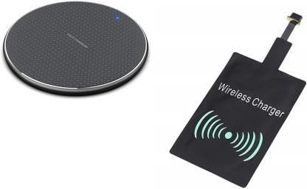

**CHAPTER 7**

**REFERENCES**

1. Randall, J. F., & Jacot, J. (2002). The performance and modeling of 8 photovoltaic materials under variable light intensity and spectra. In World Renewable Energy Congress VII & Expo (No. LPM-CONF-2002-006).
2. Choi, S. S., & Lim, H. S. (2002). Factors that affect cycle-life and possible degradation mechanisms of a Li-ion cell based on LiCoO 2. Journal of Power Sources, 111(1), 130-136.
3. Vullers, R. J., Van Schaijk, R., Visser, H. J., Penders, J., & Van Hoof, C. (2010). Energy harvesting for autonomous wireless sensor networks. IEEE Solid-State Circuits Magazine, 2(2), 29-38.
4. Raghunathan, V., Kansal, A., Hsu, J., Friedman, J., & Srivastava, M. (2005, April). Design considerations for solar energy harvesting wireless embedded systems. In Proceedings of the 4th international symposium on Information processing in sensor networks (p. 64). IEEE Press.
5. Li, Yin, and Ronghua Shi. "An intelligent solar energy-harvesting system for wireless sensor networks." EURASIP Journal on Wireless Communications and Networking 2015.1 (2015): 179.
6. Boicea, V. A. (2014). Energy storage technologies: The past and the present. Proceedings of the IEEE, 102(11), 1777-1794.
7. Jiang, X., Polastre, J., & Culler, D. (2005, April). Perpetual environmentally powered sensor networks. In Proceedings of the 4th international symposium on Information processing in sensor networks (p. 65). IEEE Press.
8. Pukhrem, S. (2013). A photovoltaic panel model in MATLAB/SIMULINK. Faculty of Electrical Engineering, Wroclaw University of Technology. Disponible en: https://www. research gate. net/publication/255721161_A_PHOTOVOLTAIC_PAN EL_MODEL_IN_MATLABSIMULINK.
9. Akhtar, F., & Rehmani, M. H. (2015). Energy replenishment using renewable and traditional energy resources for sustainable wireless sensor networks: A review. Renewable and Sustainable Energy Reviews, 45, 769-784.
10. Ongaro, F., Saggini, S., & Mattavelli, P. (2012). Li-ion battery-supercapacitor hybrid storage system for a long lifetime, photovoltaic-based wireless sensor network. IEEE Transactions on Power Electronics, 27(9), 3944-3952.
11. Sumathi, S., Kumar, L. A., & Surekha, P. (2015). Application of MATLAB/SIMULINK in Solar PV Systems. In Solar PV and Wind Energy Conversion Systems (pp. 59-143). Springer International Publishing.
12. Sumathi, S., Kumar, L. A., & Surekha, P. (2015). Solar PV and wind energy conversion systems: an introduction to theory, modeling with MATLAB/SIMULINK, and the role of soft computing techniques. Springer.
13. Hande, A., Polk, T., Walker, W., & Bhatia, D. (2007). Indoor solar energy harvesting for sensor network router nodes. Microprocessors and Microsystems, 31(6), 420-432.
14. Minami, M., Morito, T., & Morikawa, H. (2005). Biscuit: A battery-less wireless sensor network system for environmental monitoring applications. In In Proc. of the 2nd International Workshop on Networked Sensing Systems.









